**Task 21: Install Prometheus and Grafana on a EC2 machine, connect Prometheus to Grafana, and create a dashboard to view metrics.**

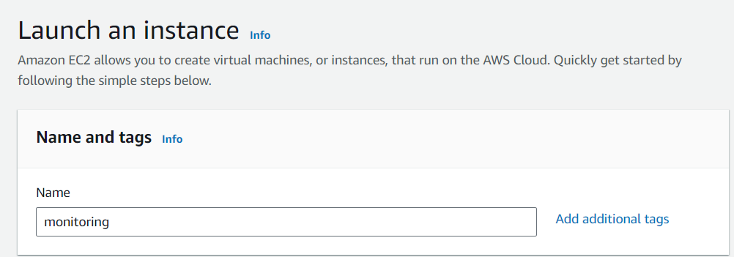

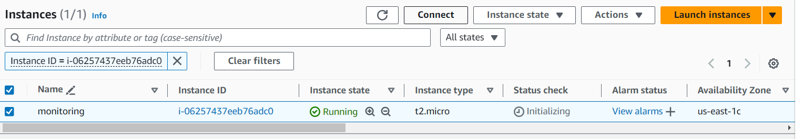

1. **Install-Prometheus:**

Vi **install-prometheus.sh**

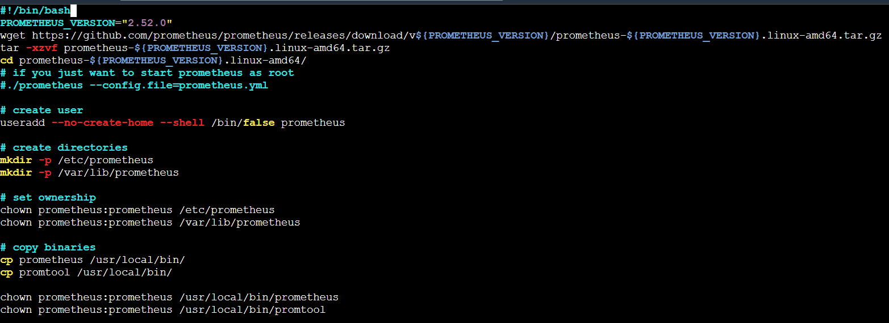

**Execute install-prometheus.sh**

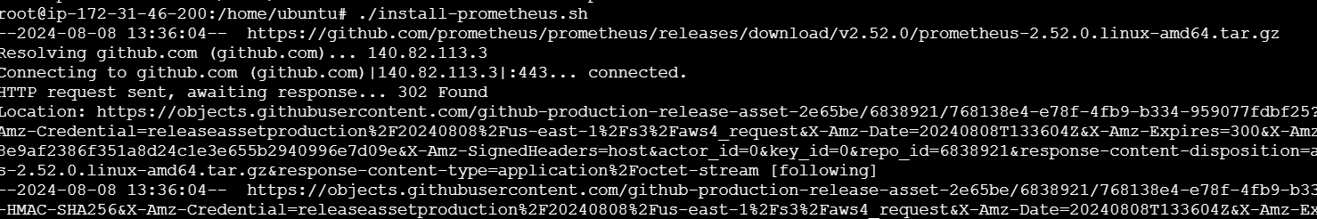

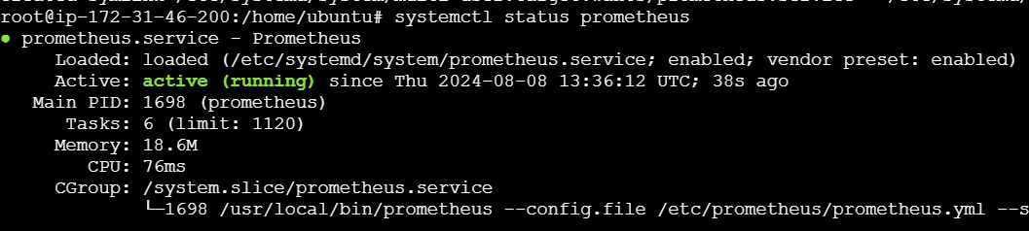

**Open port no: 9090**

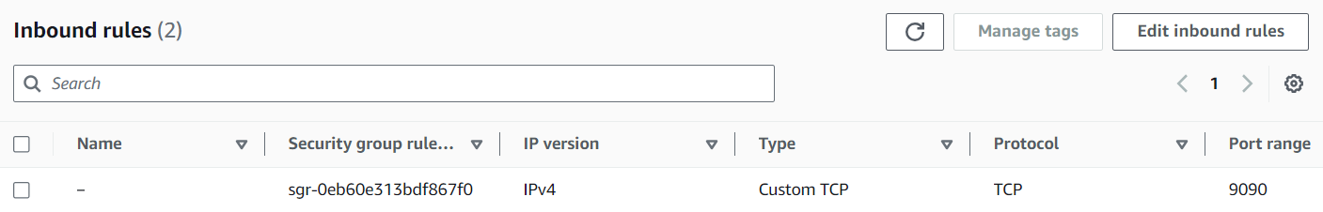

**Copy ip address and paste it in browser**

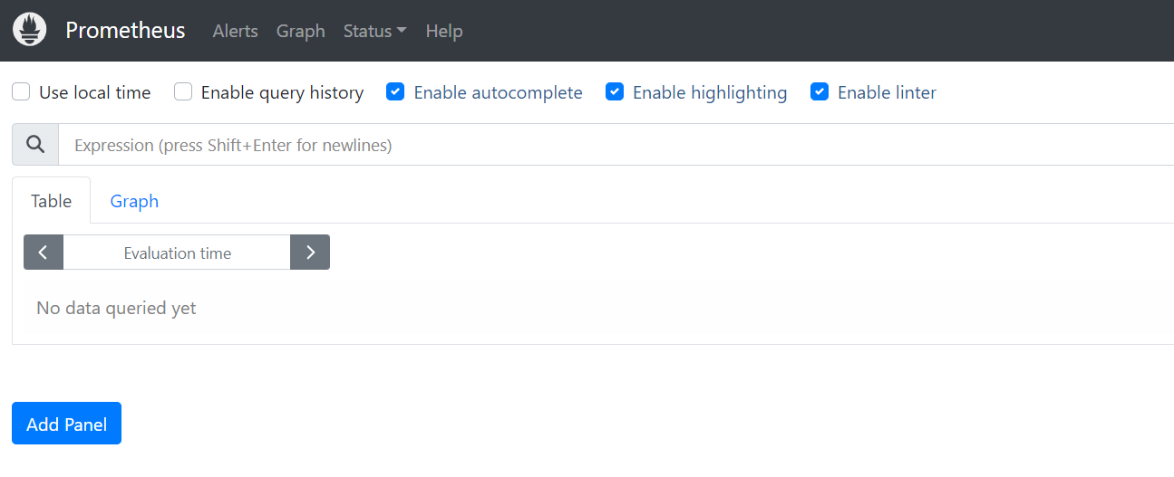

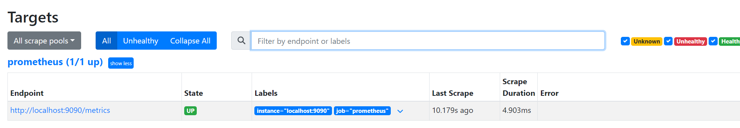

1. **Install node exporter:**

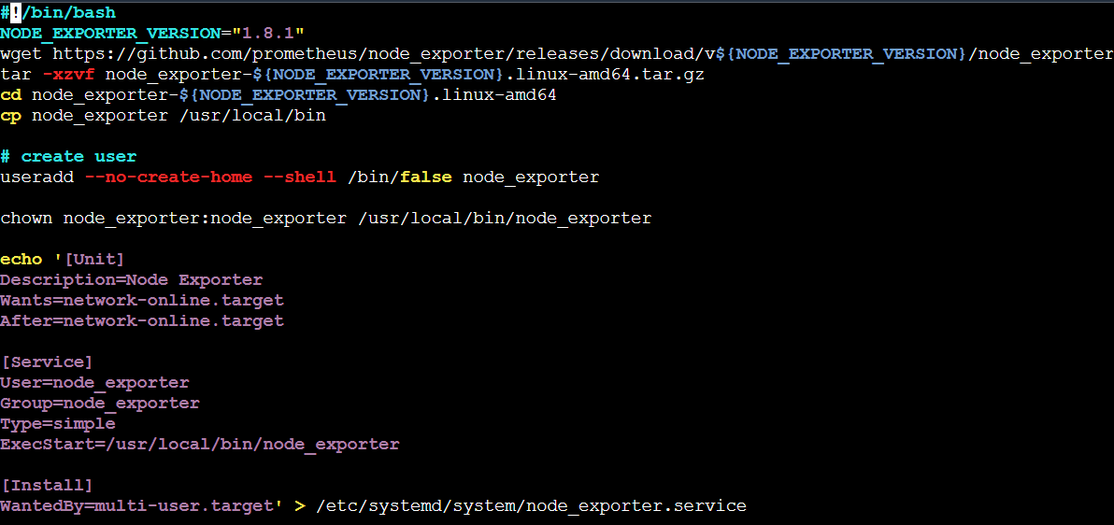

**Execute install-nodeexporter.sh**

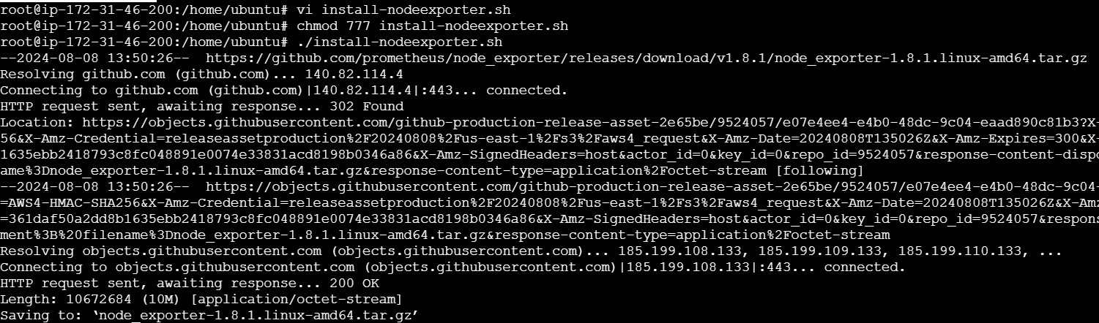

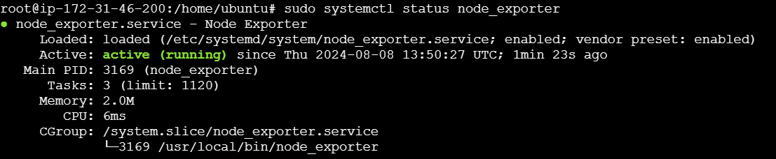

**Open port no: 9100**



**Copy ip address and paste it in browser**

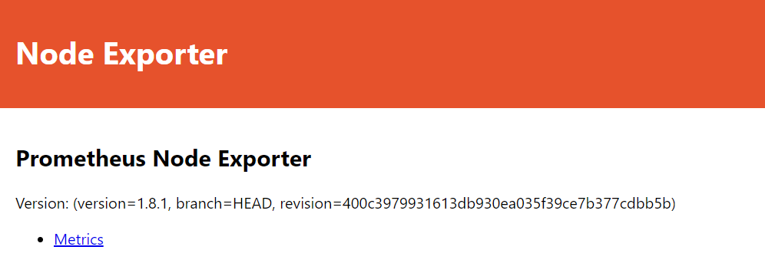

1. **Install Grafana:**

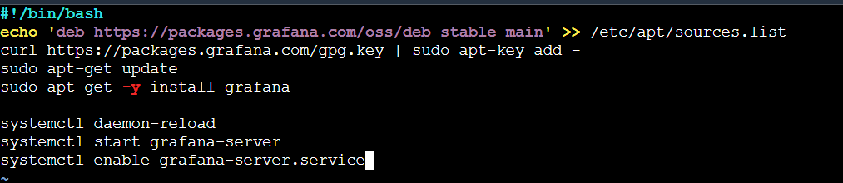

**Execute install-grafana.sh**

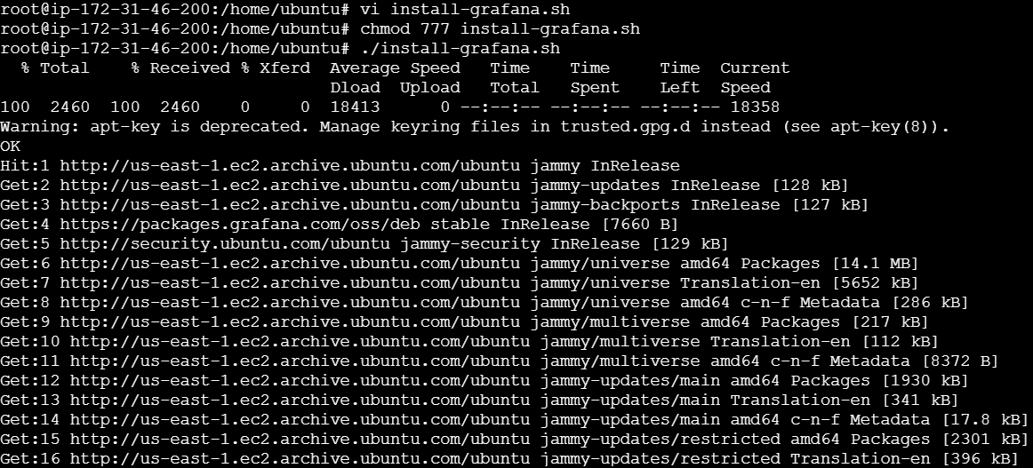

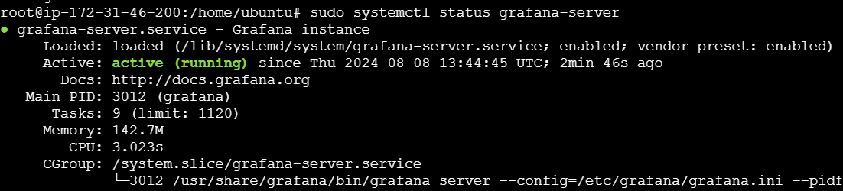

**Open port no: 3000**

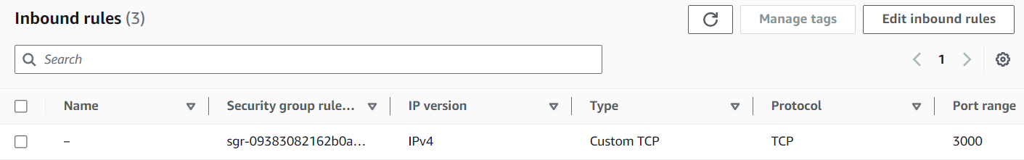

**Copy ip address and paste it in browser**

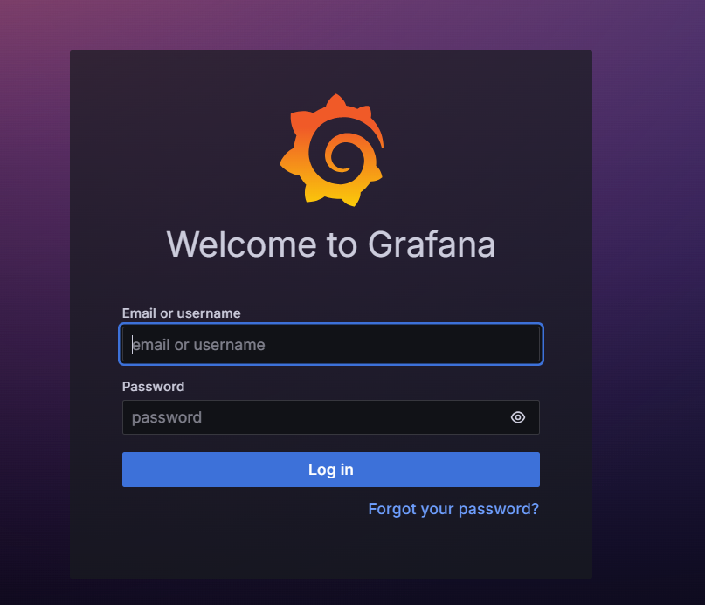

**Initially give admin as login and admin as password. After that change the password.**

1. **Connect Prometheus to Grafana:**

**Add Prometheus in Grafana**

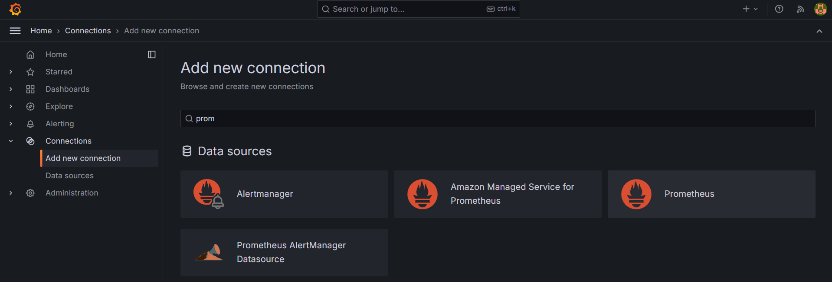

**Add new data source**

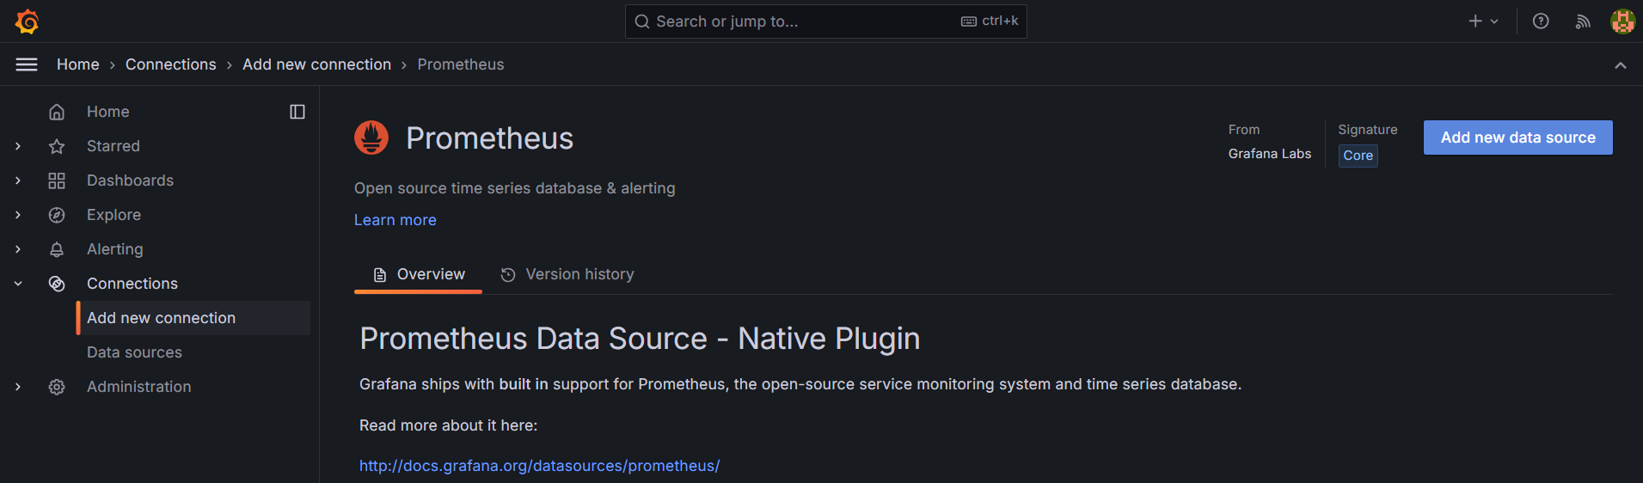

**Copy and paste the Prometheus ip address in grafana**

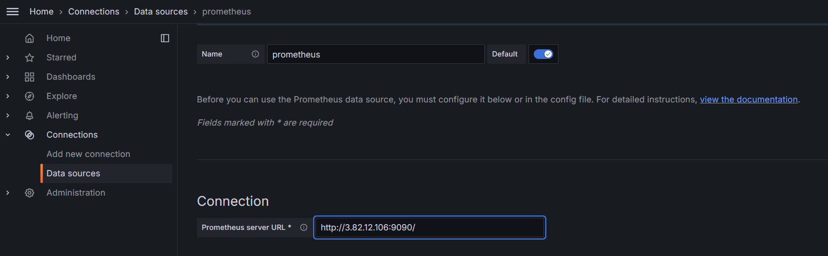

**Click save and test**

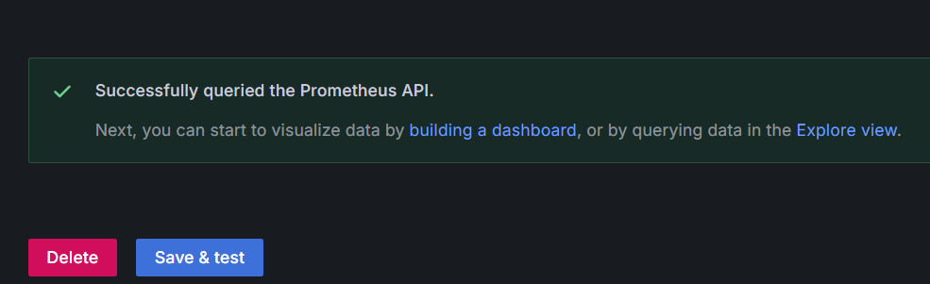

**Prometheus configuration file:**

**While install Prometheus, Promrtheus.yaml file created. get into that file using nano editor**

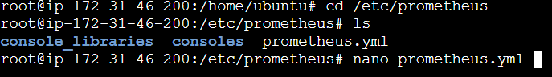

**Add node exporter in Prometheus.yaml file:**

**Change local host 9100 [node exporter port no:]. Save the file [ctrl+x 🡪 y🡪 enter]**

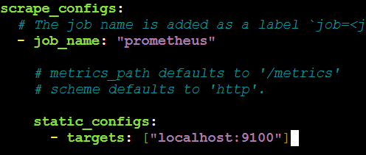



**Refresh the Prometheus page. Click status 🡪 targets**

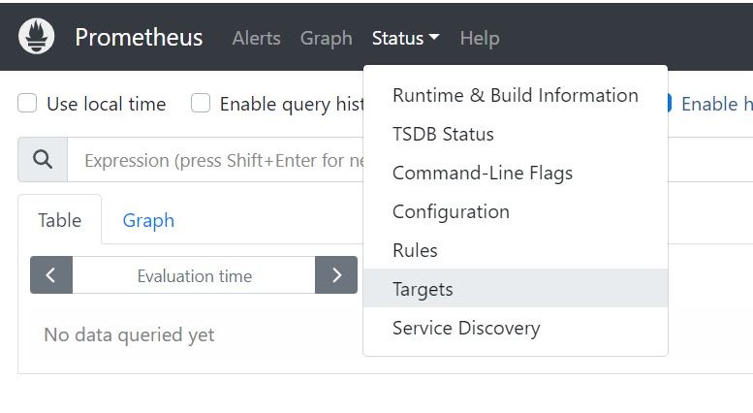

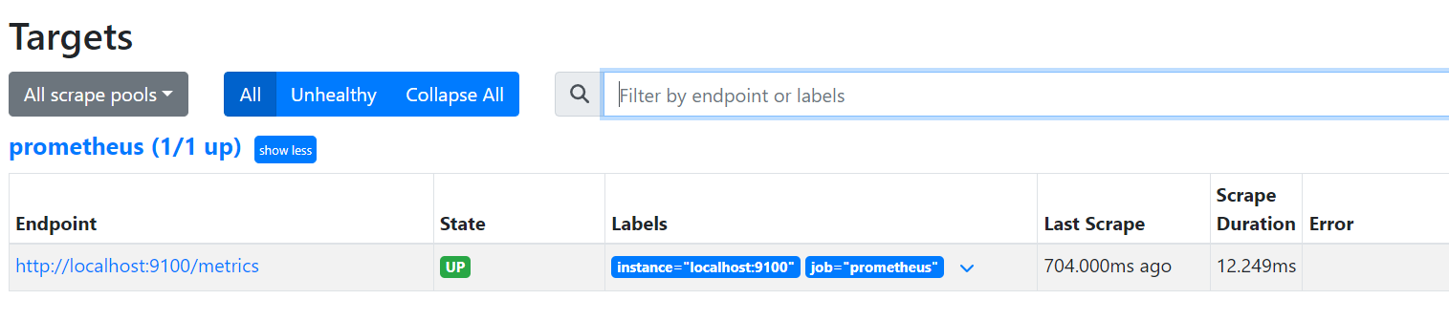

1. **Create a dashboard to view metrics:**

**Goto Grafana page click dashboard🡪 new 🡪 import 🡪**

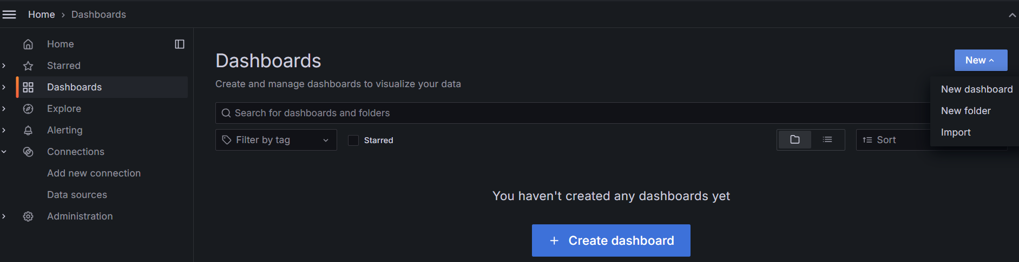

**give 1860 [pre build dashboard] click load**

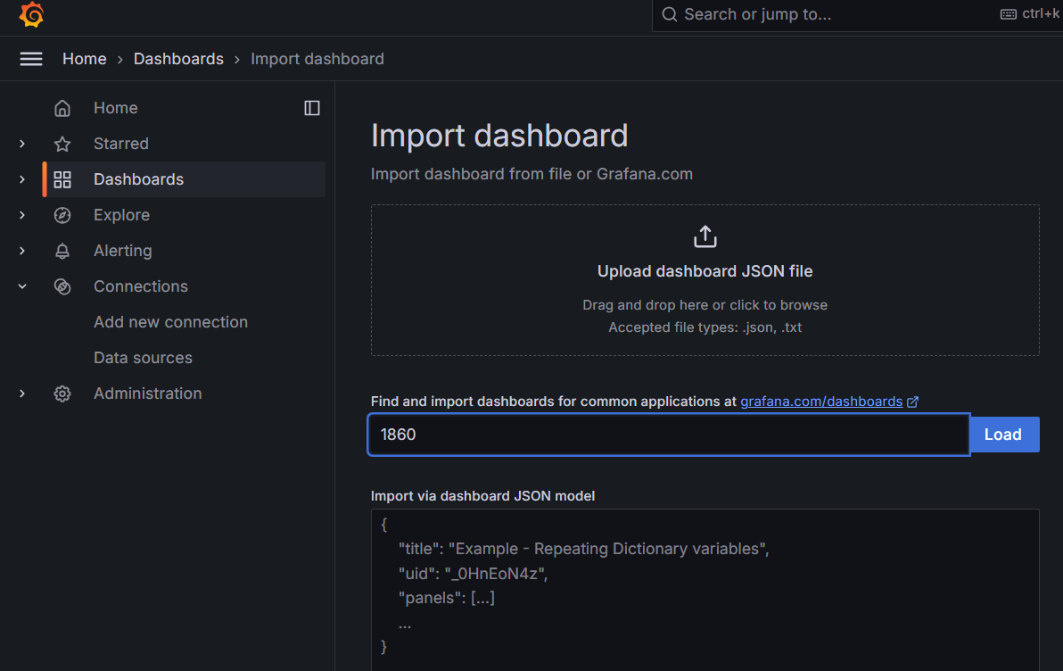

**Select source ad Prometheus. Click 🡪 import**

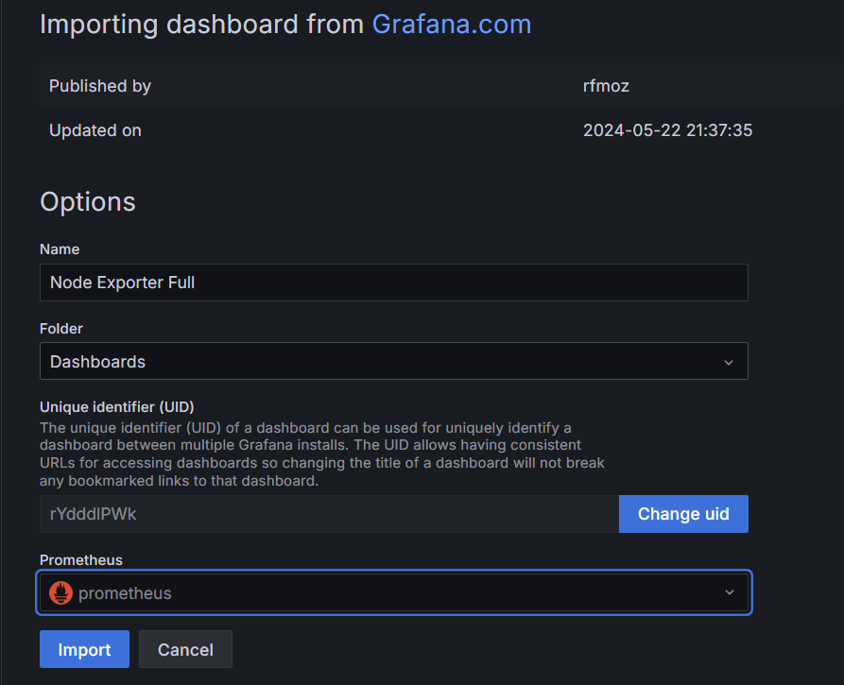

**Click last 5 mint**

